**Ans the question number-1**

1)

a) What is illustration in MS Word?

Ans: MS Word means to visual elements like chart ,image ,shapes interested to enhance or clarify content.

Prepare document with inserting following:

* Picture

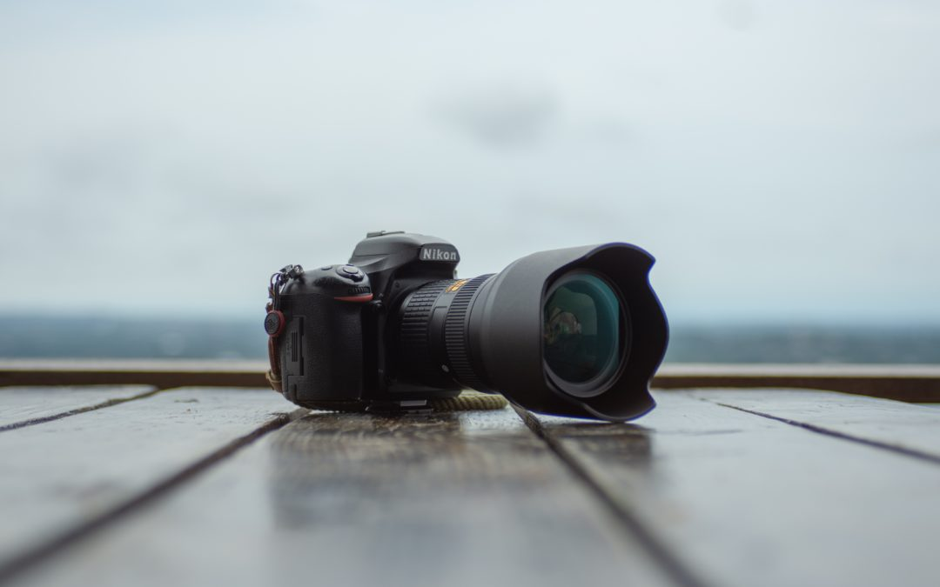

* Online picture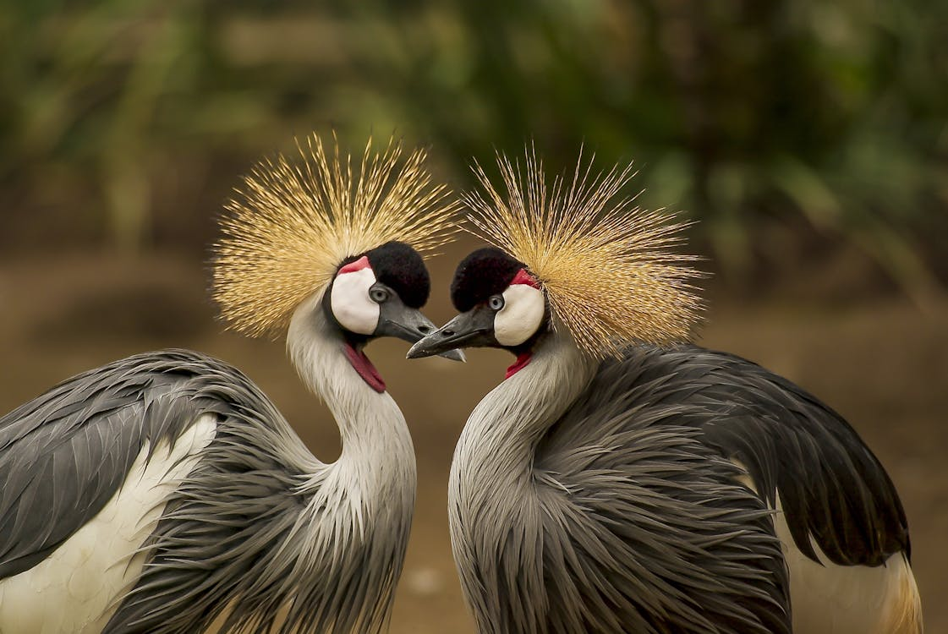
* Shapes

* SmartArt
* A chart
* Screenshot

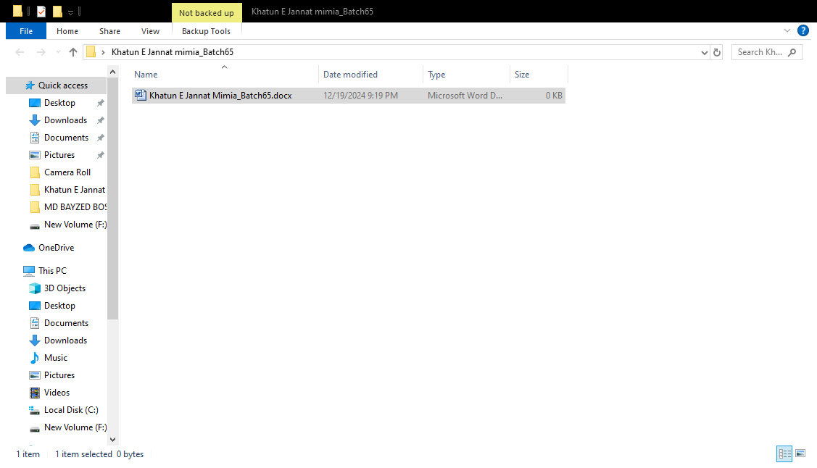

**Insert more than 2 shapes and group and ungroup the shapes**

**Group**

**Ungroup**

**Ans to the QS No C**

**Ans to the QS No : d**

|  |  |  |  |  |
| --- | --- | --- | --- | --- |
| January Tests | | | | |
| Surname | Name | English | German | Computer |
| Xuereb | Norbert | 85 | 42 | 98 |
| Spiteri | Richard | 53 | 45 | 75 |
| Briffa | Paola | 42 | 25 | 48 |
| Borg | Clive | 55 | 85 | 82 |
| Caruana | Michelle | 45 | 45 | 25 |

**C:\Program Files (x86)\Microsoft Office\MEDIA\CAGCAT10\j0285750.wmf**

**Ans to the Qs No: b**

Bangladesh, officially the People's Republic of Bangladesh, is a country in South Asia. It is the eighth-most populous country in the world and seventh most densely populated with a population of 173,562,364 in an area of 148,460 square kilometres (57,320 sq mi). Bangladesh shares land borders with India to the north, west, and east, and Myanmar to the southeast. To the south, it has a coastline along the Bay of Bengal. To the north, it is separated from Bhutan and Nepal by the Siliguri Corridor, and from China by the mountainous Indian state of Sikkim. Dhaka, the capital and largest city, is the nation's political, financial, and cultural centre. Chittagong is the second-largest city and the busiest port. The official language is Bengali, with Bangladeshi English also used in government. Islam is the official and largest religion and Bengali Muslims form the largest ethnoreligious group in the country.

Practical Preparation